BI

**Step 1: Application and Screening**

* **How to Apply & Submit and Application**
* **Federal Resume Template**
* **Eligibility**
* **FAQ**

**Step 2: Phase I**

* **Testing Overview**

**Step 3: Required Information**

* **10 Steps to Naturalization**
* **US Citizenship Checklist**
* **US Citizenship Eligibility Worksheet**
* **N-400 Instructions**

**Step 4: Meet and Greet**

**Step 5: Phase II**

* **Testing Overview**

**Step 6: Physical Fitness Test (PFT)**

* **Testing Overview**
* **Events**
* **Training Tips**

**Step 7: Conditional Appointment Offer**

**Step 8:**  **Background Investigation**

* **Social Media Guidelines**

**Step 9: Basic Field Training Course (BFTC)**

* **Overview**
* **Training Academy Overview**
* **Glock Manual**
* **Glock Preventative Maintenance**
* **Critical Incident Response Group**

**Finish: Placement**

* **Field Office Locations**

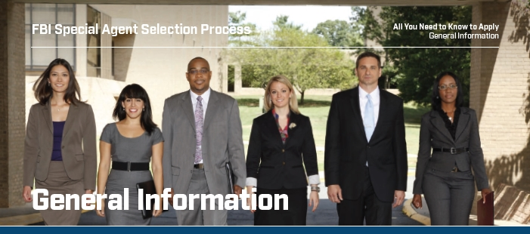

**Welcome**

Interviewing a subject for an ongoing investigation in the morning, testifying in court before lunch, planning an

operation with Intelligence Analysts and partners in the afternoon and speaking at a community event in the

evening — this is just one day in the life of a Special Agent.

As a Special Agent, every day is different. In fact, every career path is different. It’s a position that takes unique skills,

perspectives and backgrounds. The two things all Special Agents share are a drive to help keep our nation safe and

pride in making a difference in the communities they serve.

FBI Special Agents are responsible for conducting sensitive national security investigations and enforcing more

than 300 federal statutes. As an FBI Special Agent, you may work on cases involving terrorism, counterintelligence,

cybercrime, organized crime, white-collar crime, public corruption, civil rights violations, financial crime, bribery,

bank robbery, extortion, kidnapping, air piracy, interstate criminal activity, fugitive and drug-trafficking matters

and other violations of federal statutes.

FBI Special Agents must:

»» Adhere to the highest standards of conduct,

especially in maintaining honesty and integrity.

»» Undergo a rigorous background investigation,

credit checks and a polygraph test in order to

obtain a Top-Secret Clearance.

»» Maintain a high level of fitness necessary to complete Academy training and throughout their career.

»» Pass a medical exam, which includes but is not

limited to, meeting visual and hearing standards.

»» Successfully complete approximately 21 weeks

of employment as a Special Agent trainee while

housed at the FBI Academy in Quantico, VA.

»» Upon graduation from the FBI Academy and

throughout their career, be available for worldwide

assignment on either a temporary or long-term

basis. Applicants should ensure that their families

are prepared for and support this move.

»» Work a minimum of 50 hours a week, which

may include irregular hours, and be on call 24/7,

including holidays and weekends.

»» Carry a firearm and be willing to use deadly force,

if necessary.

»» Be willing and able to participate in arrests, execution of search warrants and other dangerous assignments.

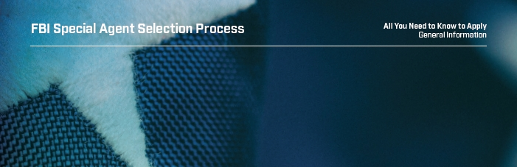

**Mission. Priorities. Values.**

**The mission** of the Federal Bureau of Investigation (FBI) is to protect the American people and uphold the Constitution of the United States.

**The priorities** of the FBI are to:

1. Protect the United States from terrorist attacks.

2. Protect the United States against foreign intelligence operations and espionage.

3. Protect the United States against cyberattacks and high-technology crimes.

4. Combat public corruption at all levels.

5. Protect civil rights.

6. Combat transnational/national criminal organizations and enterprises.

7. Combat major white-collar crime.

8. Combat significant violent crime.

**The core values** of the FBI are:

»» Rigorous obedience to the Constitution of the

United States.

»» Respect for the dignity of all those we protect.

»» Compassion

»» Fairness

»» Uncompromising personal and institutional integrity.

»» Accountability by accepting responsibility for our actions and decisions, and the consequences of our actions and decisions.

»» Leadership, both personal and professional.

»»Diversity

**The Big Picture**

The Special Agent Selection System (SASS) is a mentally and physically challenging process designed to identify

the most capable applicants. Those who make it through the process become part of an elite team that keeps

our country safe. The SASS typically takes one year to complete, often longer. An explanation of the steps in the

process to become a Special Agent can be found on the next few pages.

